All About Me

Name:………………………………………………………………………………………………………………………………..

This form gives you a chance to say what you think and feel about school. You can ask someone to help you fill it in.

What do you like doing most in school?

……………………………………………………………………………………………........................................................

.................................................…………………………………………………………………………………………………

What do you like doing least at school?

……………………………………………………………………………………………........................................................

.................................................…………………………………………………………………………………………………

What are you good at school?

……………………………………………………………………………………………........................................................

.................................................…………………………………………………………………………………………………

What do you find difficult in school?

……………………………………………………………………………………………........................................................

.................................................…………………………………………………………………………………………………

Is there anything that you would like help with?

……………………………………………………………………………………………........................................................

.................................................…………………………………………………………………………………………………

What are your hobbies/interests?

……………………………………………………………………………………………........................................................

.................................................…………………………………………………………………………………………………

What makes you happy?

……………………………………………………………………………………………........................................................

.................................................…………………………………………………………………………………………………

What makes you sad?

……………………………………………………………………………………………........................................................

.................................................…………………………………………………………………………………………………

Is there anything that makes you worry about school?

……………………………………………………………………………………………........................................................

.................................................…………………………………………………………………………………………………

Please write anything else about yourself that you consider to be important.

……………………………………………………………………………………………........................................................

.................................................…………………………………………………………………………………………………

……………………………………………………………………………………………........................................................

Thank you for sharing your thoughts.
Please return to school for the attention of Mrs Newnham
Primary KS2: Summer Holiday Homework
Name………………………………………………………………………………………………………………………………………………………………
Book Review
The book I read was

Plot - What happened in the story? What was your favourite moment in the story?

Characters – who were the main characters? What were they like? What did you find interesting about them? Did the characters change throughout the story?

Themes – what were the main ideas /issues in the story? What did it make you think about?

Personal response – Did you enjoy the book? State clearly and honestly how the book affected you. Have you learnt anything from the book? Would you recommend this book to other people?

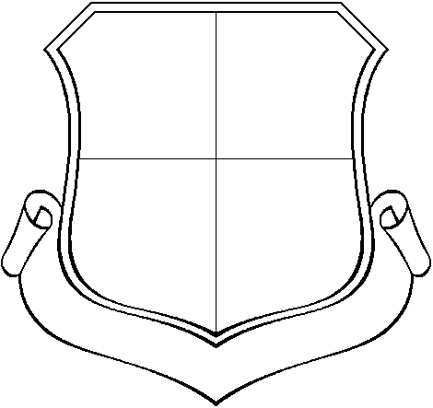
In each part of the shield draw something about yourself – a favourite thing, family, favourite subject , pets etc.

St Brigid’s shield has a motto which means ‘Strength and Gentleness’.
In the bottom of your shield write a motto for yourself.

