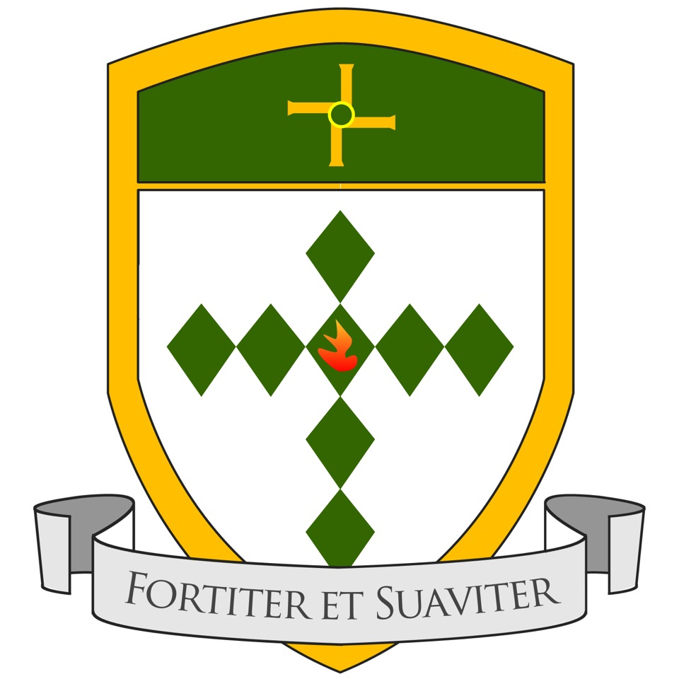
St. Brigid’s School
Denbigh

Prospectus

Plas-yn-Green, Denbigh, LL16 4BH
01745 815228

Headteacher:
Mrs. Leah Crimes

Chair of Governors:
Mr. A. J. Hannigan
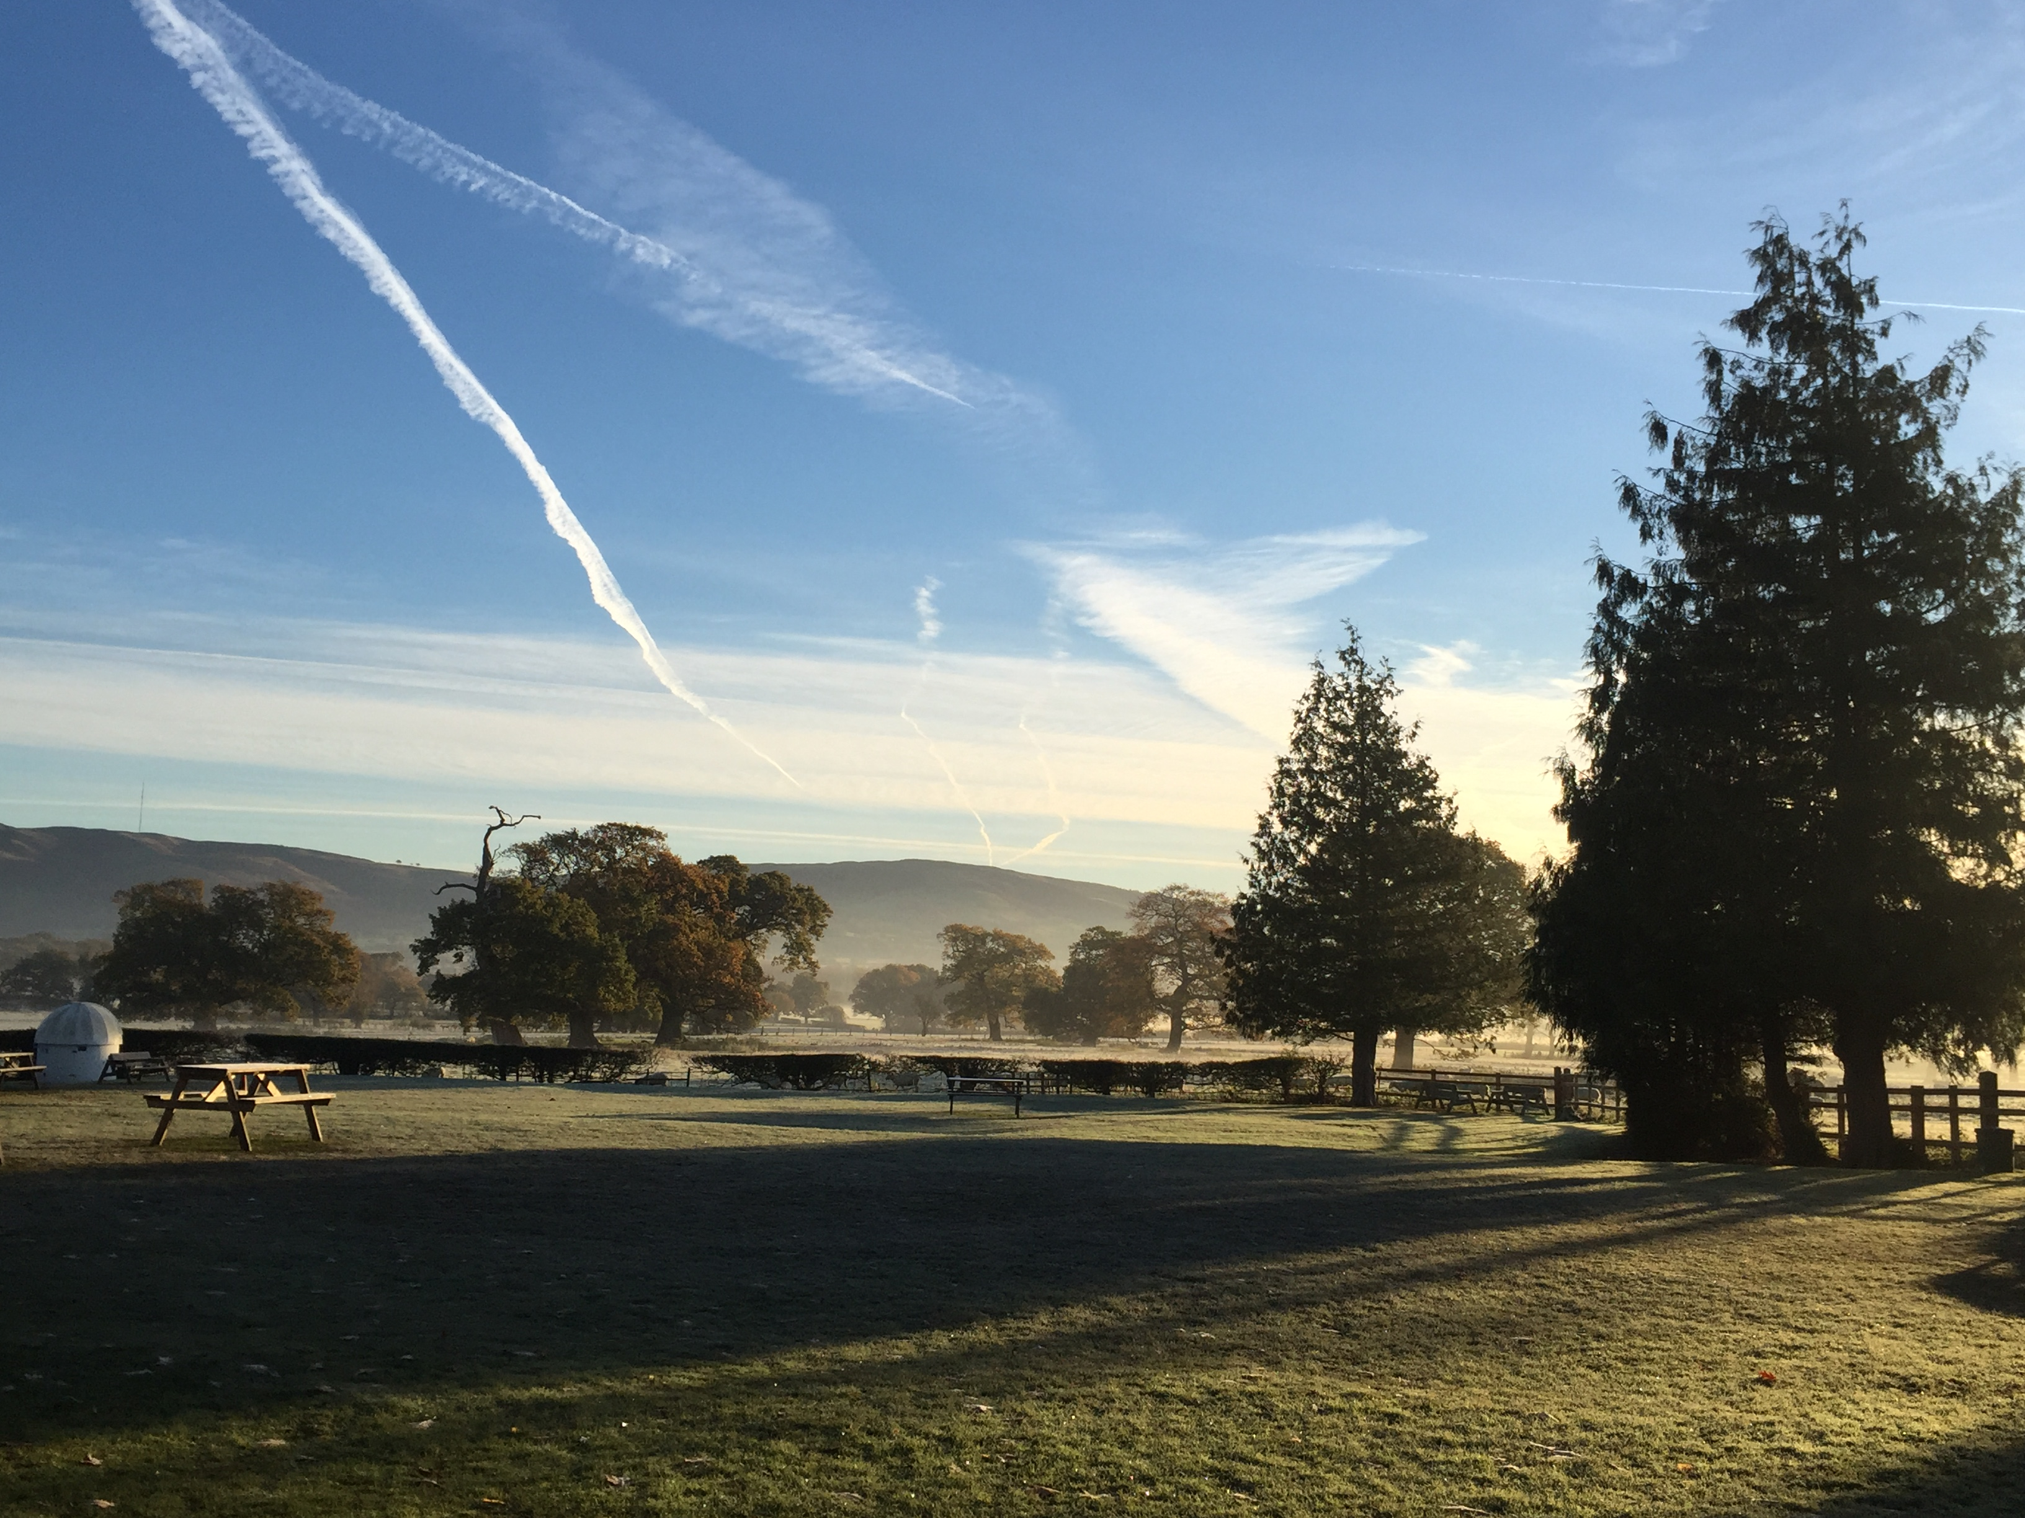

Foreword by the Headteacher

Welcome to St. Brigid’s school. As a past pupil of the school, I am incredibly proud to be welcoming you to our very special and unique community – St. Brigid’s is a small school with a big heart, and we build on the legacy of those who have come before us. Those who have attended St. Brigid’s and who work with us know that St. Brigid’s is more than just a school- everyone who passes through our doors becomes a part of our family.

St. Brigid’s is a Voluntary-Aided 3-19 school in the local authority of Denbighshire. We are a school with a designated religious character and follow the Catholic tradition. The school is very proud of its traditional values and high standards. At St. Brigid’s we promote excellence through the development of our young people as successful learners, confident and caring individuals, well-rounded and responsible citizens who contribute to society. We are justifiably proud of the achievements of our pupils; not only our outstanding academic results, but also in the fields of arts, sports and in the wider community.

Our school was established in 1939, by the Congregation of St. Brigid, and set up in premises in the town of Denbigh. In 1943, the nuns moved the school from Park Street to the present premises, and the school became St. Brigid’s Convent School, catering for children from the age of 4 to 18. In later years, it was known as Brigidine Convent.

In 1996, the school became the first Maintained (state) Boarding School in Wales. With changes introduced in 1999 by the Schools Standard and Framework Act, the School became a Voluntary-Aided school supported by the Denbighshire Local Education Authority. In 2013 boarding closed and St Brigid’s became a day school only.

St Brigid’s serves a large catchment area stretching from Llandudno in the West to the Welsh Borders in the East, and beyond Ruthin in the South.

We pride ourselves as being a ‘family’ school. As the oldest 3-19 school in Wales, we are able to nurture and develop our pupils from Nursery, until they leave us for university and the world of work. We strive to provide all of our pupils with an excellent education, allowing each individual to attain their optimum intellectual, spiritual, emotional and physical development.

We are delighted to share our school community with you in a small way via our prospectus, and look forward to welcoming you into school in the future.

God Bless you and your families.

Mrs. Leah Crimes MA NPQH FRSA MCCT
Pennaeth/Headteacher

The School Ethos

To inspire and be inspired

Aims

The Aim of St Brigid’s School is to provide an excellent Christian Education which will enable each individual pupil to develop their talents to the full and produce the qualities of character, both spiritual and academic which will lead them naturally into responsible adult life. St Brigid’s provides an environment within which the values of the Catholic church are of prime importance.

The Pastoral Care of Pupils
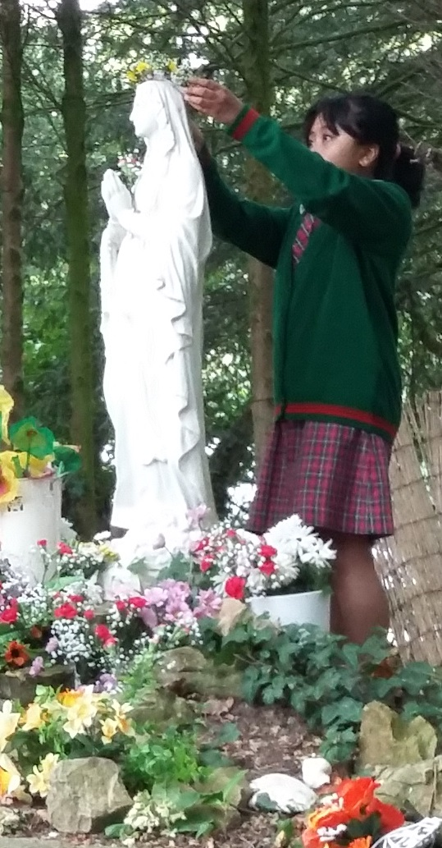
The pastoral care system at St Brigid’s School is based on the Christian principals of respect, consideration, care and concern for every member of the school community. Pastoral Care is centred on the form group. In the first instance, Form tutors deal with pupils’ educational and personal difficulties, and usually problems are resolved at this level. Sometimes however they need to be passed on to the relevant Head of Year. The school has a Child Protection Policy in line with the All Wales Child Protection procedures.

The Pastoral aims of the school are:

- to nurture a concerned and caring school community
- to help each pupil enrich her/his personal life
- to help each pupil to make meaningful and relevant choices
- to help create and maintain an orderly and happy environment where pupils can grow and learn.

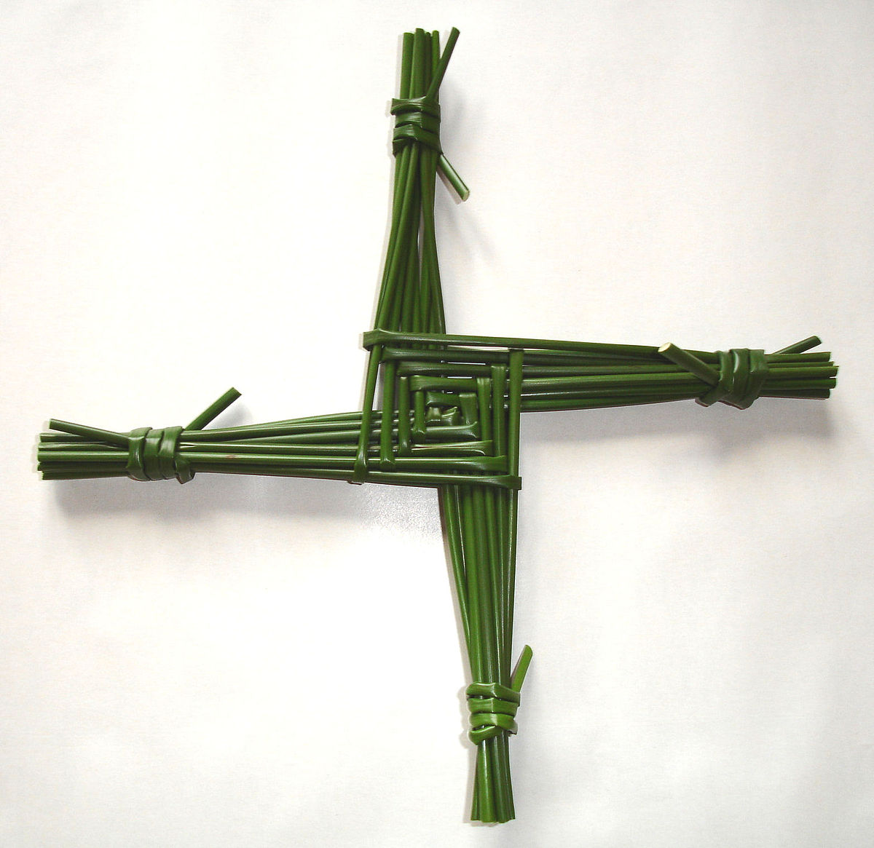Religious Education

The School has a Roman Catholic Foundation, and in accepting a place, parents and the child must agree that their education will follow the Roman Catholic ethos, and they will enter fully into the religious life of the school.

All pupils attend school assemblies and follow a course of Religious Education which is included in the core subjects to GCSE. Religious Studies is an optional subject offered at Advanced Level. Parents / carers have the right to withdraw their children from collective worship and RE lessons at any phase of the school if they choose to. We ask that this is submitted to the school in writing.

Equality

Every pupil is to be held in equal esteem as a child of God. Their individual needs are carefully assessed and monitored in the light of their abilities, talents, previous and present experience and their full entitlement to educational and spiritual provision made to them.

The overall structures and policies and attitudes are to be kept under review in order to see that no individual adult or child is subject in any way to prejudice or discrimination in terms of their membership of the school community.

Every 2 years the school sets out its Strategic Equality plan which outlines the school commitment to equal opportunities for all regardless of race, gender, disability and other protected characteristics. Our equality plan is in line with our school ethos of valuing every individual on their merits and ensuring every pupil achieves their potential. This Equality plan can be viewed on the school website.

Our Pastoral system follows the model of best practice for 3-19 schools:

Lower School: Nursery – Year 4
Middle School: Year 5 – Year 8
Upper School: Year 9 – Year 11
Sixth Form: Year 12 – 13

Each pastoral ‘school’ is led by a Head of School and a team of Tutors. These teams ensure outstanding pastoral care and safeguarding for every child, at every phase of their development.

Curriculum

*We are currently working towards Curriculum for Wales 2022. Foundation Phase to Year 7 will follow the new Curriculum for Wales in September 2022. Years 8 – 13 will follow the existing curriculum, until it is phased out by Welsh Government*

It is the aim of the school to develop a broad balanced, relevant and differentiated curriculum which recognises the importance of the whole child.

In accordance with the national curriculum for Wales, the National Literacy and Numeracy Framework, GCSE and A Level specifications, it is the school’s aim that every pupil’s learning should be planned to enable them to experience these requirements, in a consistent and continuous manner as he/she moves through the school. As a 3 – 19 school we deliver the curriculum from Foundation Phase to Key Stage 5. There are opportunities for transition projects and learning experiences are shared across phases. We review and adapt our curriculum to meet the needs of our pupils and to ensure that all statutory elements of the curriculum are in place.

Lower School (Nursery – Year 4)

The seven areas of Learning are covered in Nursery and Reception, these are then continued into Years 1 and 2.
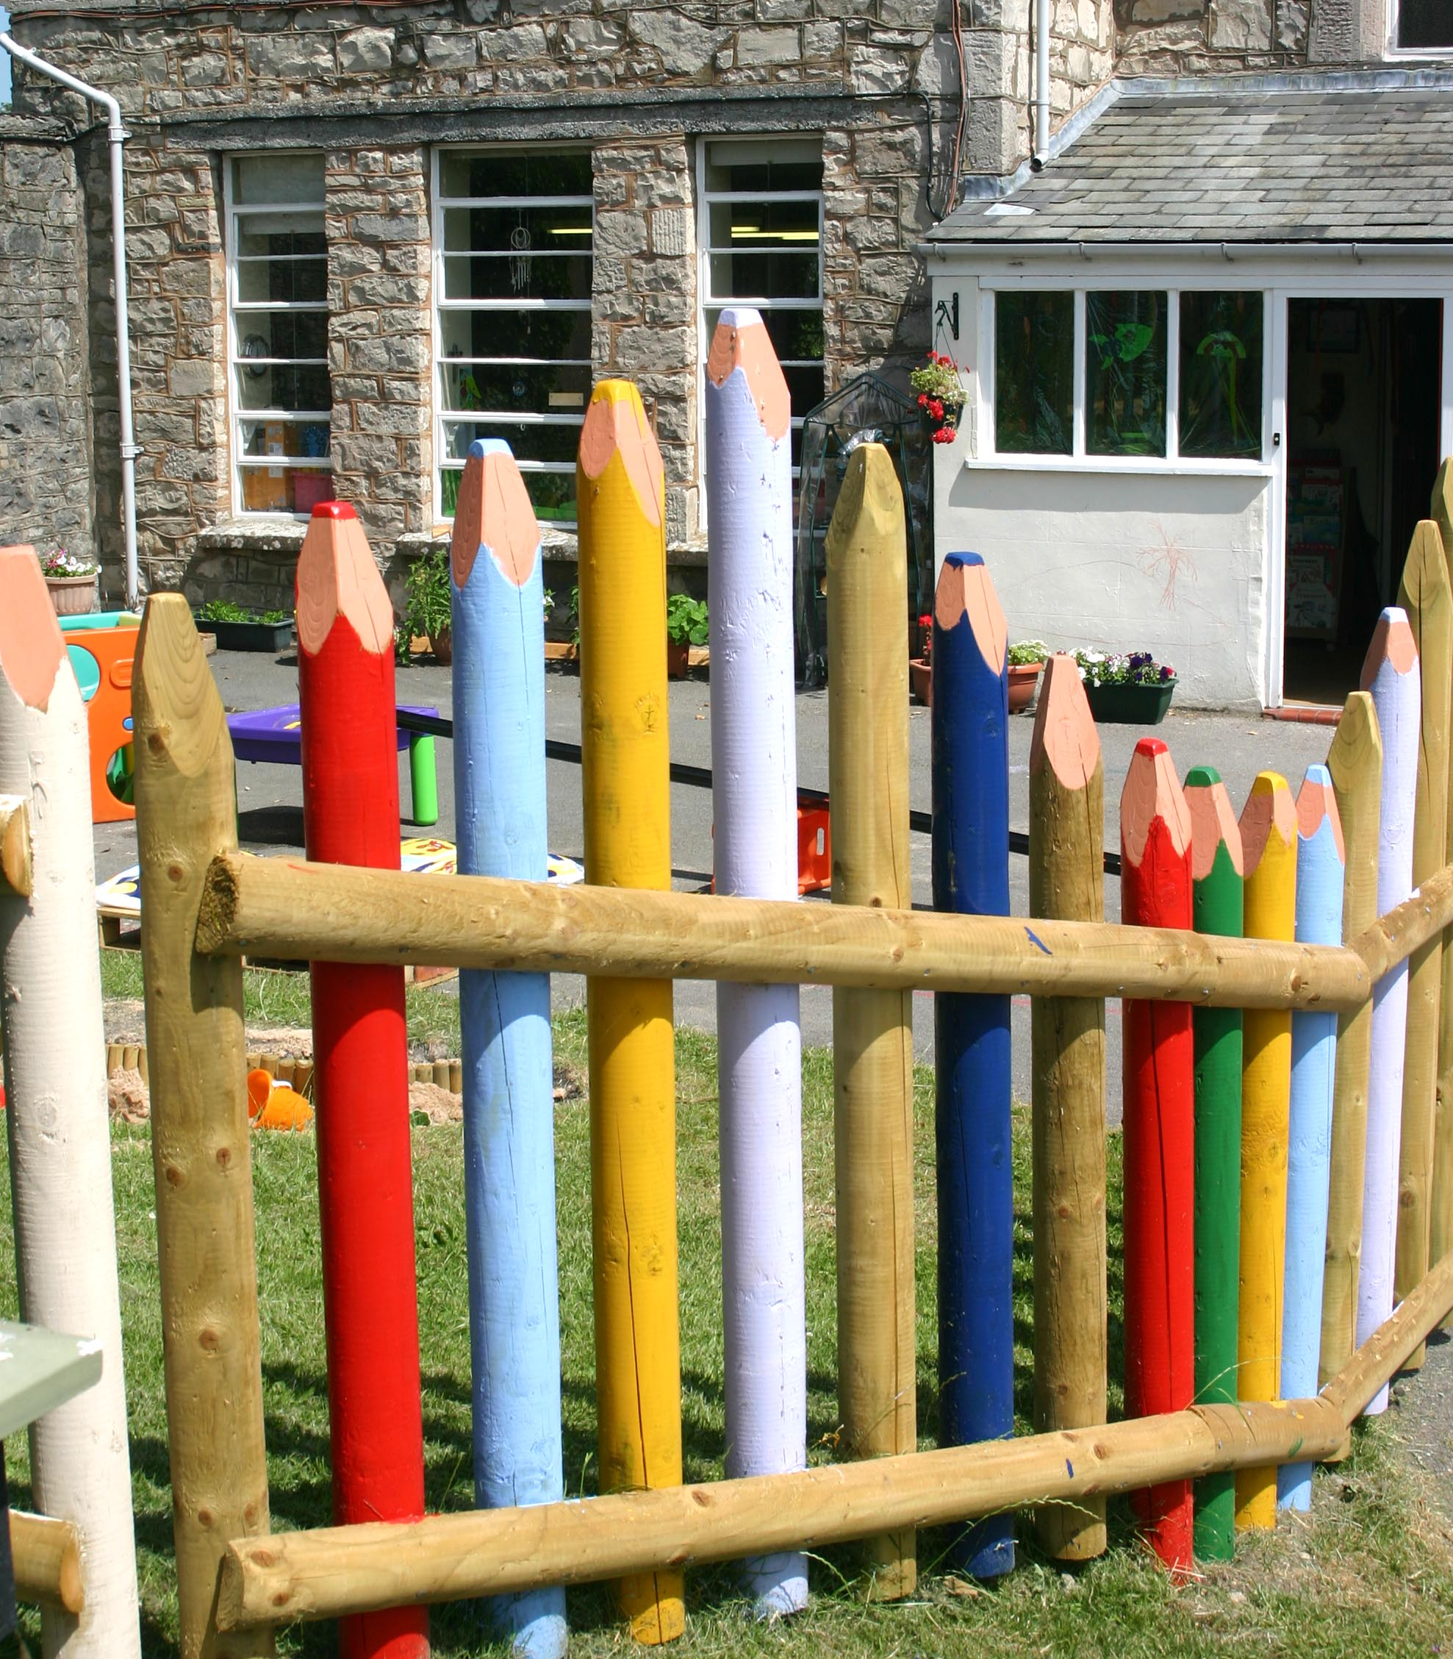
- Personal and Social Development, Wellbeing and Cultural Diversity.
- Language, Literacy and Communication Skills
- Mathematical Development
- Welsh Language Development
- Knowledge and Understanding of the World
- Creative Development
- Physical Development

Pupils are taught partially through play. There is a balance between structured learning through child-initiated activities and those directed by teaching staff.
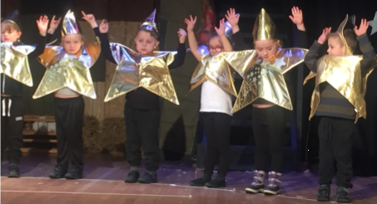

Key Stage 2 (Years 3 - 6):

English

Great emphasis is placed on Literacy Skills. Speaking, listening and writing skills are taught, encouraged, enriched and used through every aspect of school life. Handwriting and spelling skills are developed by a variety of methods. Reading is taught from the earliest stages through the appreciation and love of books, and reading schemes are used to supplement this approach as well as a wide selection of picture and story books. Drama is used to strengthen and extend language.

Mathematics

Children are given a wide range of activities and experiences, thus enabling them as they develop their numeracy skills to think logically, imaginatively and to become skilled exponents of mathematics.

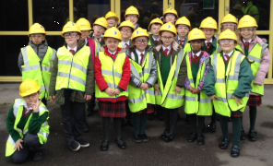Science

Pupils are taught how to develop investigative, research and evaluative skills, in order to encourage their scientific awareness.

Information and Communication Technology / Digital skills

The development of ICT skills is considered an essential part of each curriculum area, using the latest technology available in the school.

History and Geography

Through topic work, pupils develop an active investigative approach to their work which enables them to acquire the necessary knowledge, skills and attitudes required in each respective subject area.

Welsh

The teaching of Welsh as a second language is presented as an exciting, interesting and relevant experience both in the classroom situation and in the everyday life of the school. All Primary children are encouraged to join in the Urdd activities.

Music

Music is introduced to the children from the beginning of their school life as a live experience and they are taught skills which will enable them to take an increasingly active part in music making and to become a more understanding listener. In addition to class music lessons there are opportunities for children to learn to play various musical instruments with peripatetic teachers

Art/Design Technology

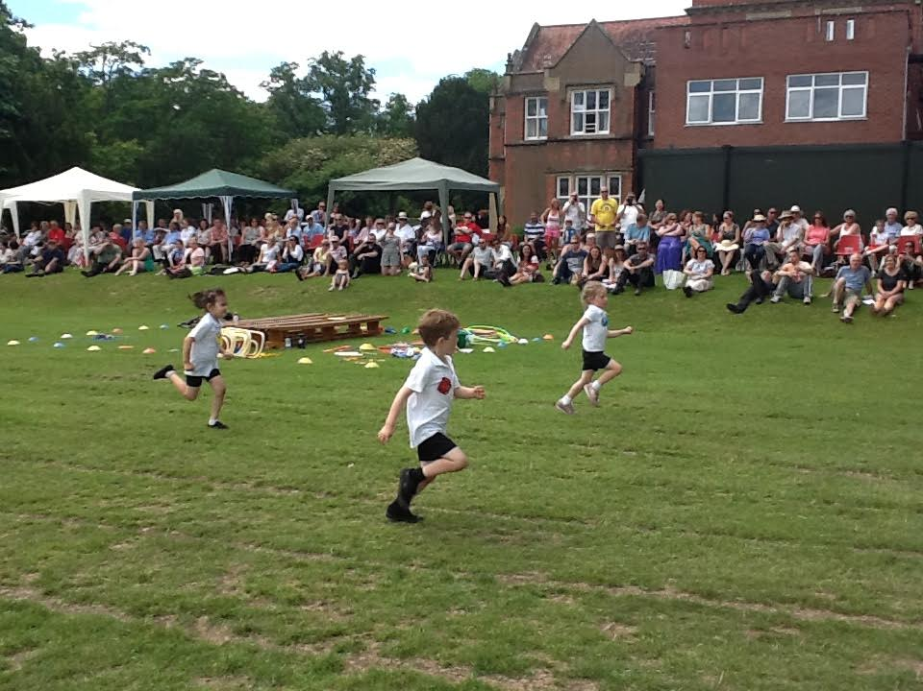Children learn to work through a variety of two and three dimensional media, such as drawing, painting and model making. Visits from local artists enrich their experiences.

Physical Education

PE is taught throughout the school. Gymnastics, movement and dance are taught indoors together with various outdoor games and activities. Years 3-6 receive swimming instruction at the local pool.

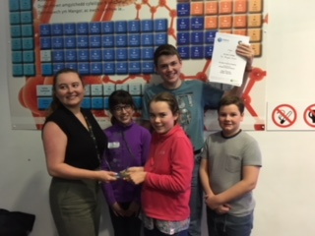
Key Stage 3 Years 7-9 (Age 11-14)

In years 7, 8 and 9 there are 2 forms and subjects are taught mainly in form groups with some setting. Pupils in these year groups follow The Welsh National Curriculum courses in Religious Education, Art, Design Technology (including resistant materials, food, textiles and information technology), Drama, Dance, Modern Foreign Languages, Geography, History, Mathematics, Sciences, Music, Physical Education, and Welsh (Second Language).

Year 9

Towards the end of Year 9, after full consultation between staff, pupils and parents, students make choices regarding their options for GCSE courses which are in keeping with their interest and ability. Care is taken to ensure that career aspirations are protected whenever possible within budgetary constraints.

Key Stage 4 Years 10 & 11 (age 14 -16)

Students take up to 12 subjects at GCSE which are chosen in Year 9. The curriculum in these years is directly related to GCSE Examinations, and students can choose from a range of optional subjects in addition to the core subjects of English, Mathematics, Sciences, Religious Education, Physical Education, Welsh Baccalaureate and Welsh.

Careers Education / PSHE

A Personal and Social Education programme is followed by all year groups. Vocational education is an integral part of this programme with particular emphasis on careers education in Years 9, 10 & 11 and is also reinforced through a programme of work experience in Year 10 and Year 12. A school based Learning Coach provides advice for pupils in addition to mentoring.

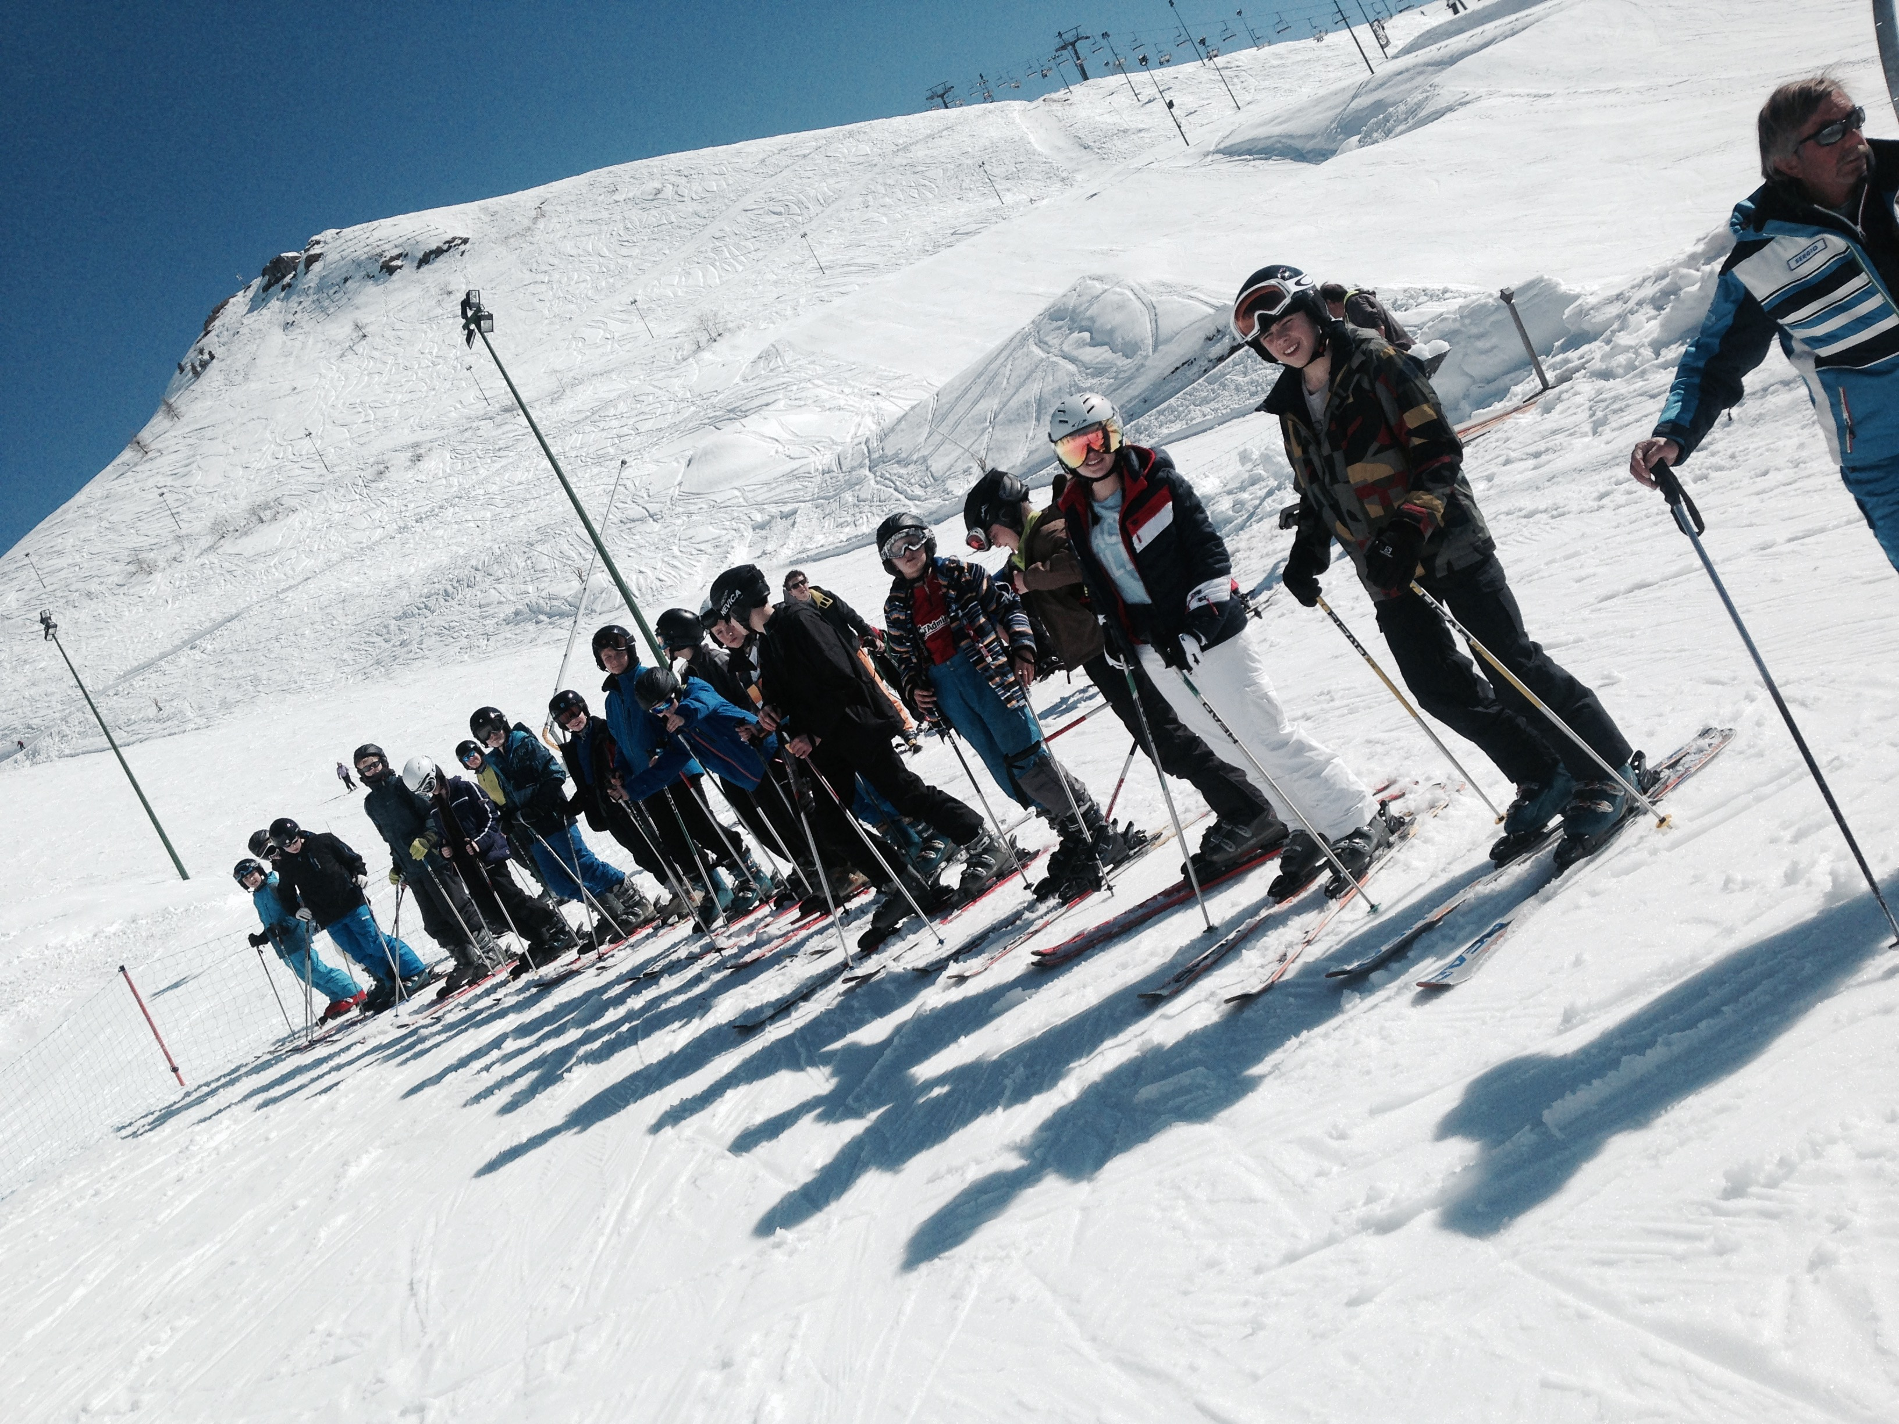

Sporting Aims and provision

The school fosters an enthusiasm for as many sporting activities as can be provided with the existing facilities. All pupils follow a course in Physical Education, and this is supplemented by after-school activities such in both Primary and Secondary Departments. Some of the clubs offered are: Orienteering, Cross-Country, Netball, Tennis, Athletics and Aerobics. There is usually an annual ski trip which is extremely popular. The school Combined Cadet Force also contribute to the sporting activities on offer for pupils from Year 9, these include climbing, canoeing and orienteering.

Sex and Relationships Education

This School incorporates in its general curriculum appropriate teaching on matters of human love, the functions of the body and an understanding of God’s creative love as embodied in human reproduction at a level suitable to the growing child at various stages of development. Sex education as such is not a subject in itself on the curriculum. However, there will be from time to time specific classes devoted to various aspects of sex education in a variety of subjects.

Moral teaching on sexual behaviour will be covered from the Catholic point of view in all subjects although the RE department may take special initiatives in this area in liaison with other subjects. Questions arise in a wide variety of topics. Teachers are asked to answer questions honestly, taking care that especially in the case of younger pupils answers are simple and straightforward and do not give rise to confusion or anxiety. Parents have the right to withdraw their child from Sex Education sessions and this can be done in writing to the Headteacher. The SRE policy is available on the school website.

The Sixth Form (Years 12-13)

St. Brigid’s is part of The Dyffryn Clwyd Dinbych Consortium, which includes:
St Brigid’s (3-19 School)
Denbigh High School (secondary school)
Llysfasi College (part of Coleg Cambria)
Coleg Llandrillo
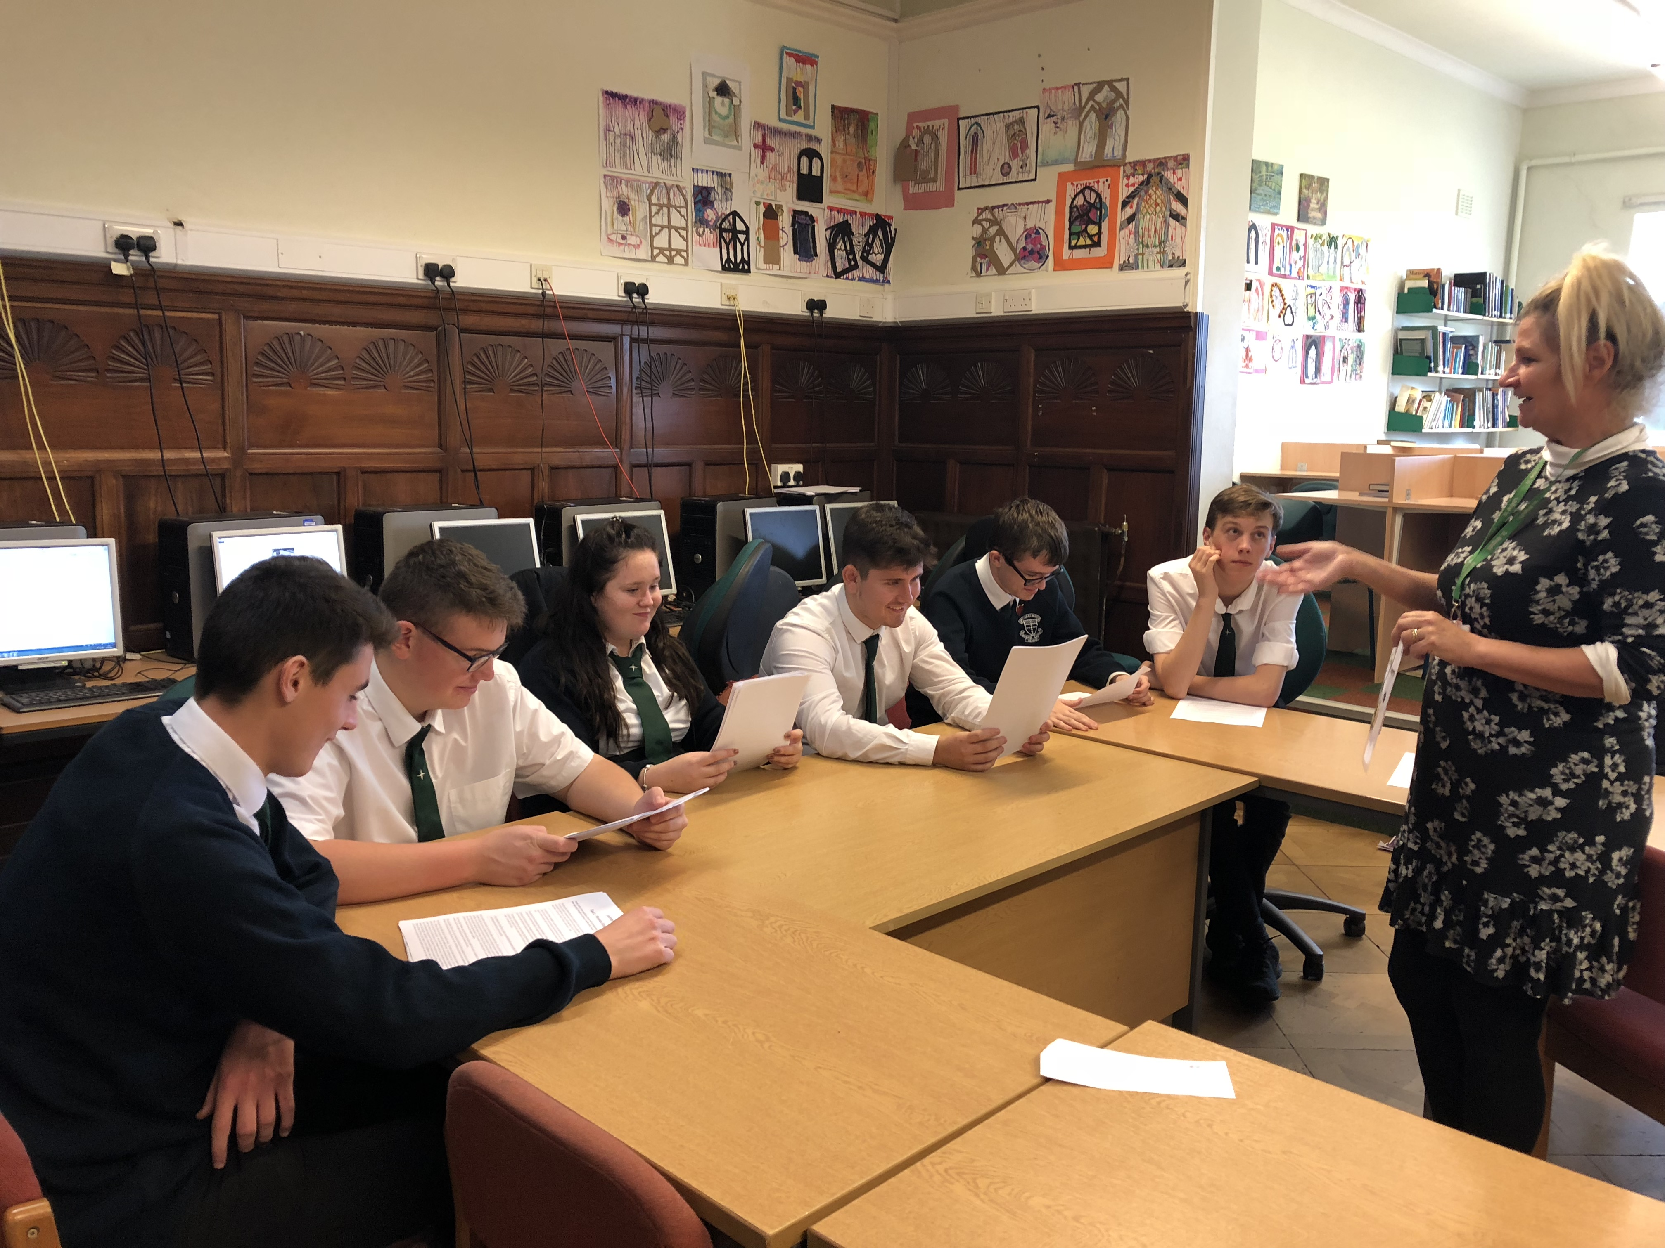As a consortium we are not only able to deliver the expectations of the Learning and Skills Measure, but surpass it, in the choice of options that are available through the consortium. The Welsh Baccalaureate is a key part of our Post 16 offer and pupils have the option to do this in conjunction with A level courses or BTEC qualifications.

Very little travel is required between schools, but where there is a need, transport is provided for the pupils. The timetable has been arranged to allow for travel time and again, little curriculum time is lost when pupils travel. Our sixth form pupils form part of our successful prefect team and assist the school in many ways including acting as Reading and Maths buddies, volunteering in and out of school and being positive role models to the younger pupils.

Destination of leavers

In 2019, 91% of Year 13 pupils continued to Education, Employment or Training, two pupils took gap years. Many of our pupils moved on to study their chosen degree level courses at Russell group universities including Oxford University.

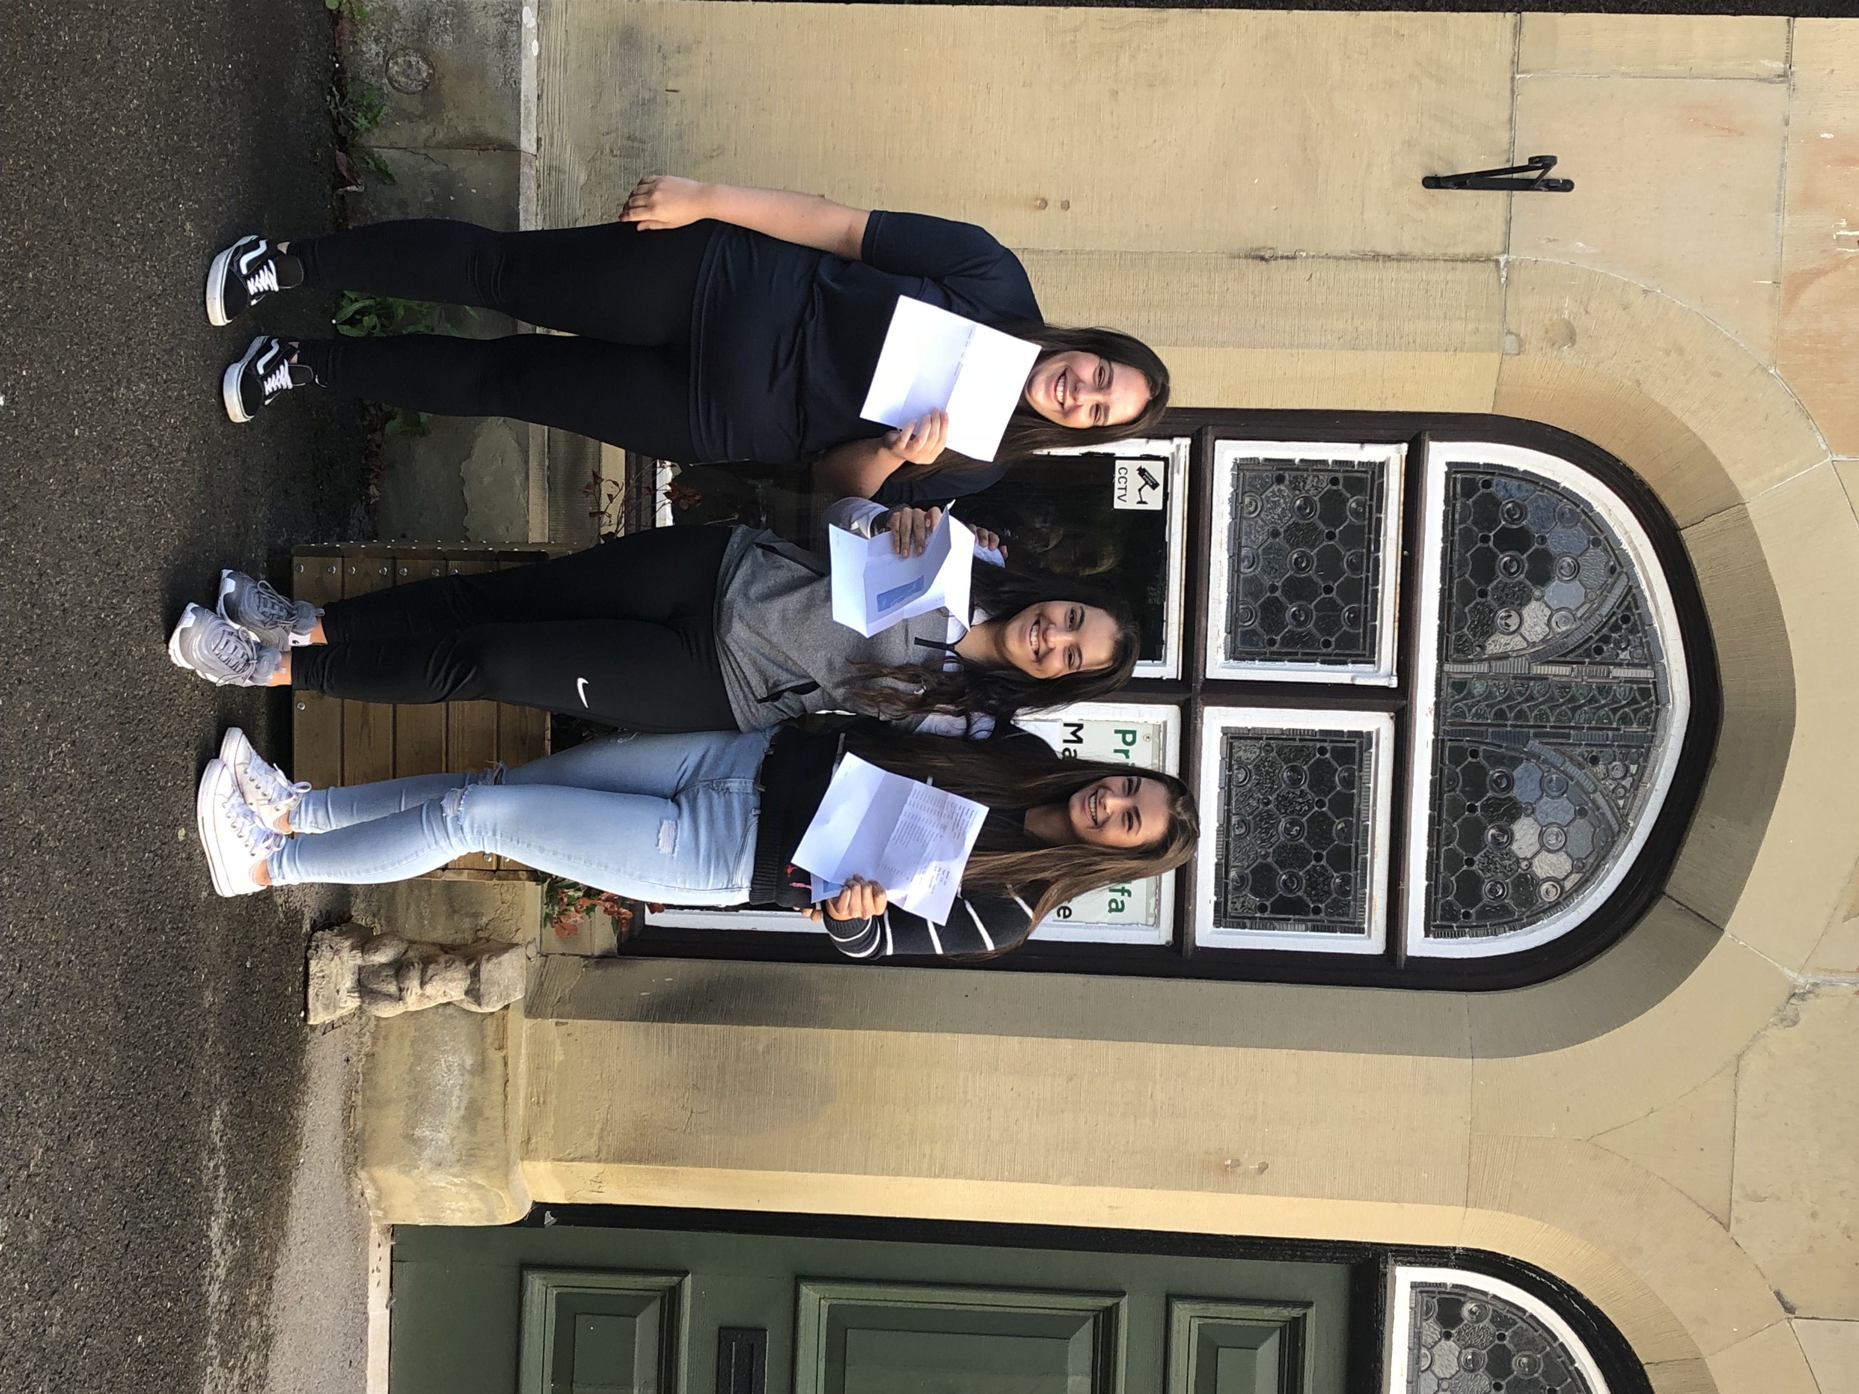In 2019, 100% of Year 11 leavers went onto education, employment or training and many chose to return to us for sixth form.

Combined Cadet Force

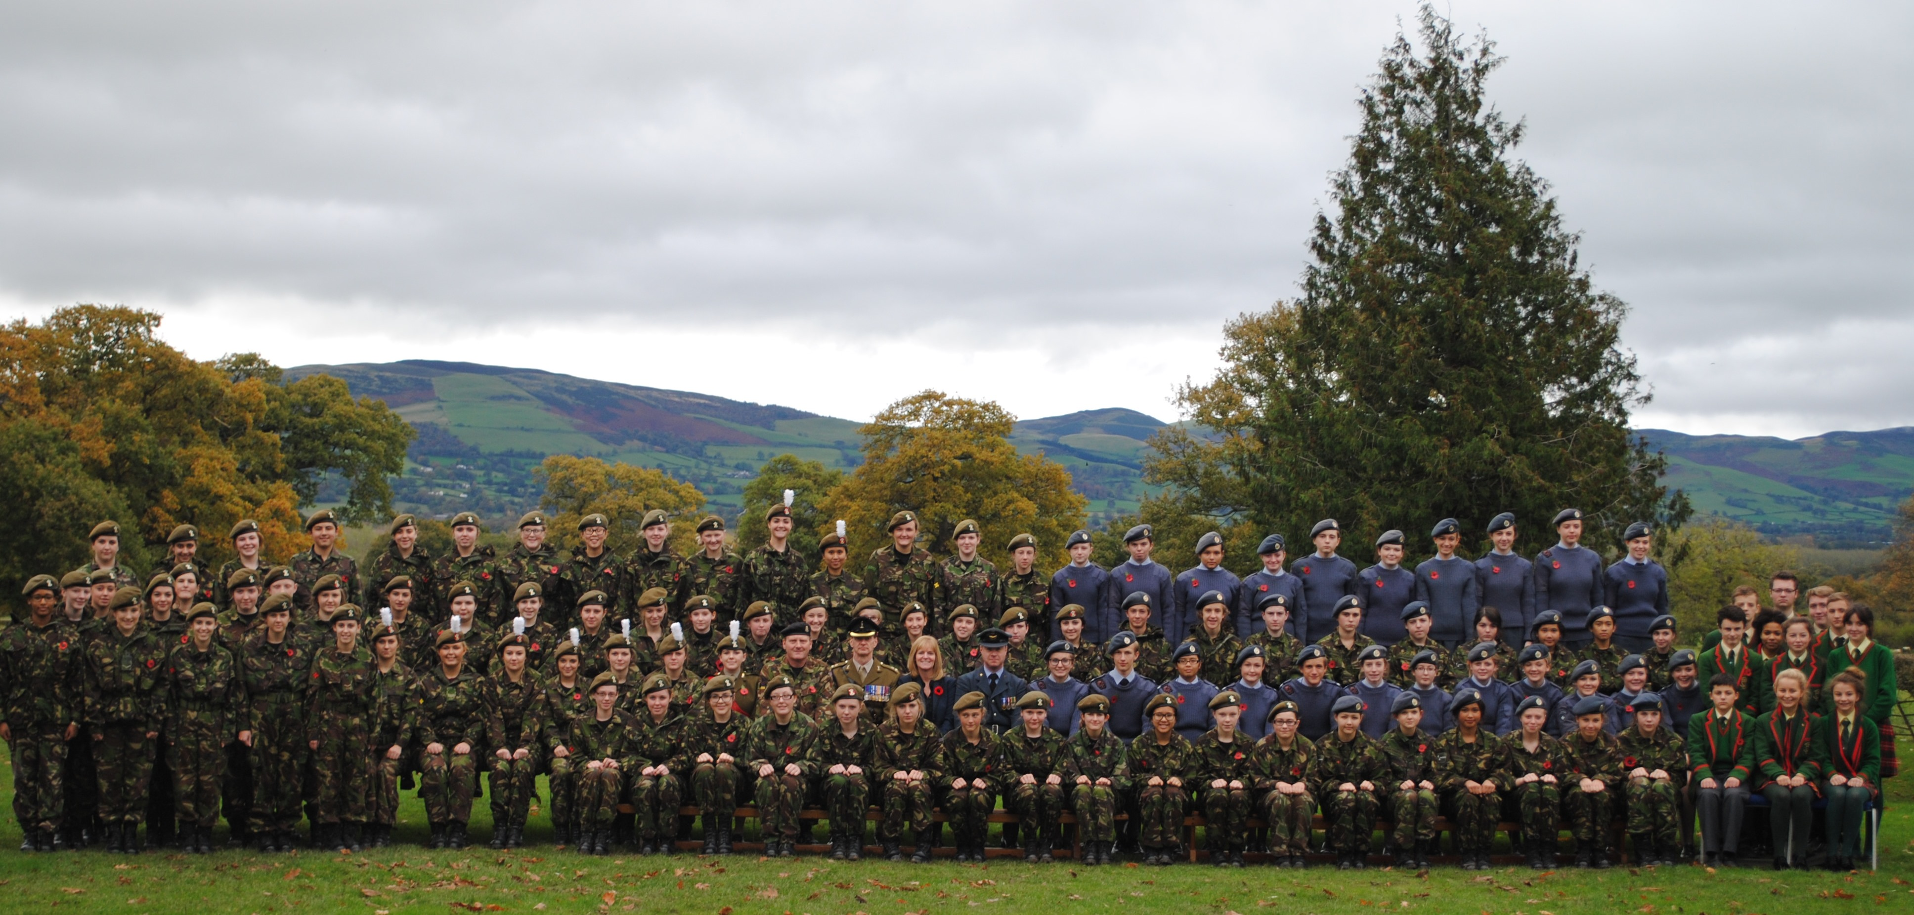

The School has a Combined Cadet Force which is available for all pupils over the age of 12. Cadets join at the end of Year 8 and are able to attend Annual Camp in June/July. The Contingent meets on a Monday evening from 3.45pm to 5.45pm. Uniform (except boots) is provided. Cadets can join either the Army or RAF Sections. The training can lead towards Advanced Proficiency Certificates and The Duke of Edinburgh’s Awards.

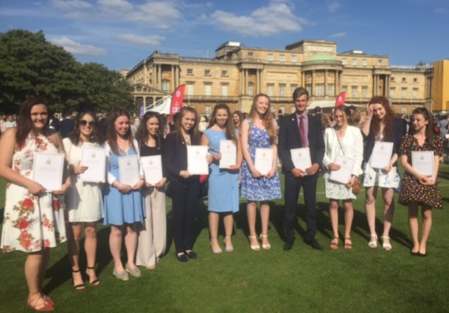There are many opportunities for Adventure Training and openings for sport and expeditions. Cadets have the chance to be selected for visits to Canada, Cyprus, Patagonia, Kenya and other locations around the world.

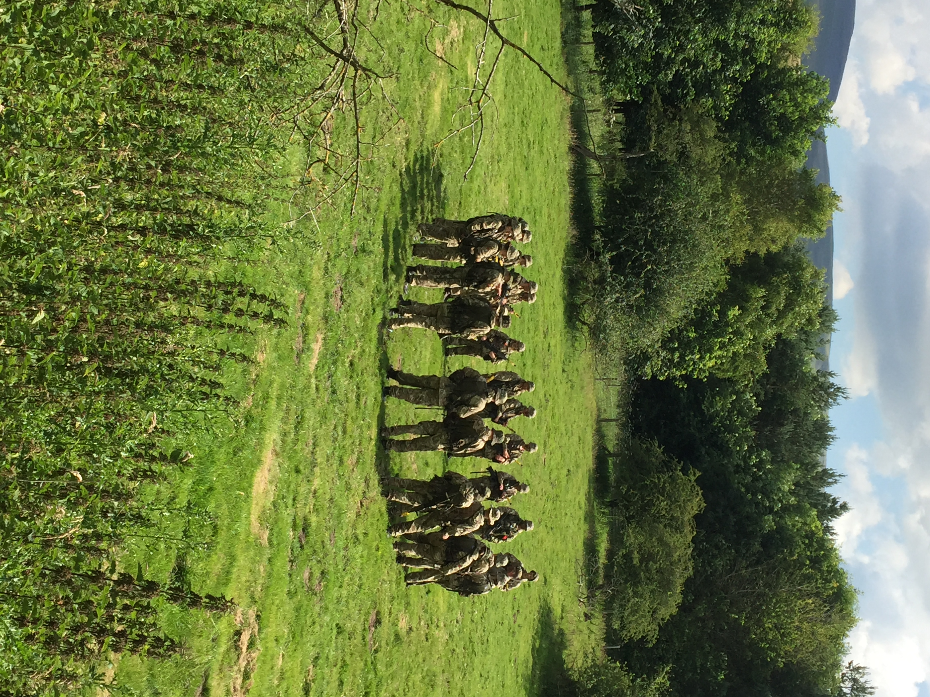

More Able and Talented pupils

There is a separate policy for the More Able and Talented (MAT) and we aim to support the most able pupils to achieve their potential where practically possible. Extracurricular opportunities are made available for these pupils to allow them to excel. The school has appointed a MAT coordinator to oversee this provision.

Provision for pupils with Additional Learning Needs

St Brigid’s School as a community reflects and celebrates diversity. Our commitment is to meet the needs of every child admitted into the school where possible, and this policy addresses our responsibility for those children with additional learning needs whether long or short term, related to physical, emotional or behavioural difficulties or learning.

We aim to be partners with parents who are the first educators of their children. We welcome those parents seeking integration into mainstream schooling for their child in the context of our Admissions Policy. Our criteria includes a statement that special consideration may be given to applications supported by an educational or other assessment of need, and we will seek to meet parental wishes as far as practicable and in the best interests of the child.

Governors have appointed an Additional Learning Needs Coordinator (ALNCO) who is responsible for Additional Learning Needs across the school. The ALNCO will ensure that for new pupils, existing statements of need are made known to all who will teach the child and that appropriate provision, within financial constraints and where practically possible, is available in all curriculum areas. A review of progress will involve both child and parents so that realistic targets can be set and monitored. Our aim is to build on the child’s strengths to allow maximum participation in all school activities.

Special attention will be given to the child’s spiritual development to reinforce the sense of dignity and value established in the individual child. It is the professional responsibility of every teacher to be alert to the onset of a special need in any pupil and liaise directly with the ALNCO, and the parents of the child.

Assessment of, and provision for the child’s needs may require assistance from outside agencies including the Educational Psychologist, Medical Officer, or Advisory Services of the Local Education Authority. Staff will have regard to the WAG “Code of Practice on the Identification and Assessment of Special Educational Needs” in addressing special educational needs. The school ALN policy can be found on the school website.

Looked After Children

Governors have also appointed a Looked After Children (LAC) Coordinator who is responsible for any children that are Looked After / in Local Authority Care. The LAC coordinator will ensure that LAC pupils’ individual needs are made known to all who will teach the child and that appropriate provision, within financial constraints and where practically possible, is available in all curriculum areas. The LAC coordinator will also schedule appropriate staff training when necessary to update staff on relevant policy and teaching approaches.

A review of progress will involve the child, the Local Authority (with responsibility for the child) and foster parents so that progress is monitored. LAC pupils will have access to all areas of the curriculum and school life to enable them to have the same opportunities as non LAC pupils. Specific LAC funding will be used to support these pupils in and out of school.

Costs to Parents

Some activities such as sports fixtures, field trips and curriculum visits may incur costs. Financial assistance is available for pupils in receipt of Free Schools Meals via the Pupil Development Grant and application for assistance should be made in writing to the Headteacher.

A charge is made for materials or ingredients for Technology Subjects to ensure costs are covered, but the pupil will be able to retain the product. Re-sits of public examinations are charged, as are individual lessons in Music, Drama or Dance which will be charged at the appropriate rate. There are many extra-curricular activities including sports clubs, ski trips, visits to the theatre and other enrichment activities. Music, Dance and Sport are offered, and Drama productions are of a high standard. There is close communication between home and school.

A full list of chargeable items are listed in the School Charging policy which is available on the school website.

Language Policy

The school is designated as an English language school but encourages the use of Welsh in and around lessons as part of our commitment to the Welsh language and culture. The school has a policy for developing pupils’ language, which recognises that success in school subjects is likely to be greater if pupils are encouraged to practise their language skills within all curriculum areas. All pupils are expected to study Welsh and all pupils have left the school with a Welsh qualification in the last 5 years.

The School actively promotes the Welsh language and culture in accordance with the Welsh Government Programmes of Study, as well as reflecting its position within the local community. The School has active participation in the Urdd.

School facilities

The Business and Facilities Manager oversees the upkeep and maintenance of the school site. We are very fortunate to have beautiful parkland surrounding the school with views of the vale of Clwyd. Facilities are shared between the whole school community and most areas are communal to all pupils. The school kitchen received a complete renovation in 2021. Toilet facilities are reported as being clean and to a high standard. All facilities conform to the standard regulations for schools in Wales.

School Security, Health & Safety

The Governing Body is responsible for ensuring the Security, Health & Safety of all persons who have access to the school, including pupils, staff, parents and other visitors. Whilst it is impossible to secure the whole site, measures have been taken to ensure access to individual buildings is controlled. Risk Assessments are in place to ensure that the safety and security of pupils, staff and visitors.

All Governors, staff and teaching assistants are subject to Disclosure and Barring Service checks (DBS), and all staff and visitors are required to sign-in at Reception.

Complaints Procedures about Curriculum and Related Matters

Under the terms of Section 23 of the Education Reform Act 1988, procedures have been laid down concerning complaints made by parents or others on specific items.

Any concerns expressed by parents and others about the school curriculum and related matters will continue to be considered and, so far as possible, dealt with through informal discussion with teachers and the Headteacher in the first instance. Where the issue is not resolved, the matter may then be the subject of a formal complaint and, if appropriate, referred to the Governing Body. If deliberations fail to provide a satisfactory response to the complainant, the issue will then be referred to a Curriculum Appeals Panel. A copy of the document detailing arrangements for the consideration of complaints is available on the school website.

Admissions

Admissions to the school are in line with our Admissions policies for Primary and Secondary which can be found on the school website. As a Voluntary Aided school, the school acts as is its own Admissions Authority. Applications to the school must be completed on the school application form which can be found on the school website or by contacting the Admissions Secretary at the school.. There are admissions into Nursery, Reception, Year 3, Year 5 and Year 7. Mid-year applications are considered on a case by case basis. As the school is regularly oversubscribed the admissions criteria are applied rigorously.

Leaving the Premises

Under no circumstances (with the exception of the sixth form) is a student allowed to leave the school during the school day without the express permission of their pastoral head. Permission is normally granted when a pupil produces written request from a parent. These requests are usually for dental or medical appointments or urgent matters which cannot be dealt with outside school hours.

Absence

All periods of absence, however short, should be covered by an explanatory note addressed to the Form tutor. When a pupil is likely to be absent from school for an extended period, the school should be informed by letter or telephone.

Holiday

The School strongly discourages holidays being taken during school terms as such absences are likely to have a negative effect on children’s education. If parents wish their children to accompany them on holidays during school time, authorised absence will only be granted in exceptional circumstance at the discretion of the headteacher, provided the appropriate holiday form is completed and returned to school in advance of the absence. Absence forms can be obtained from the Reception.

School Uniform
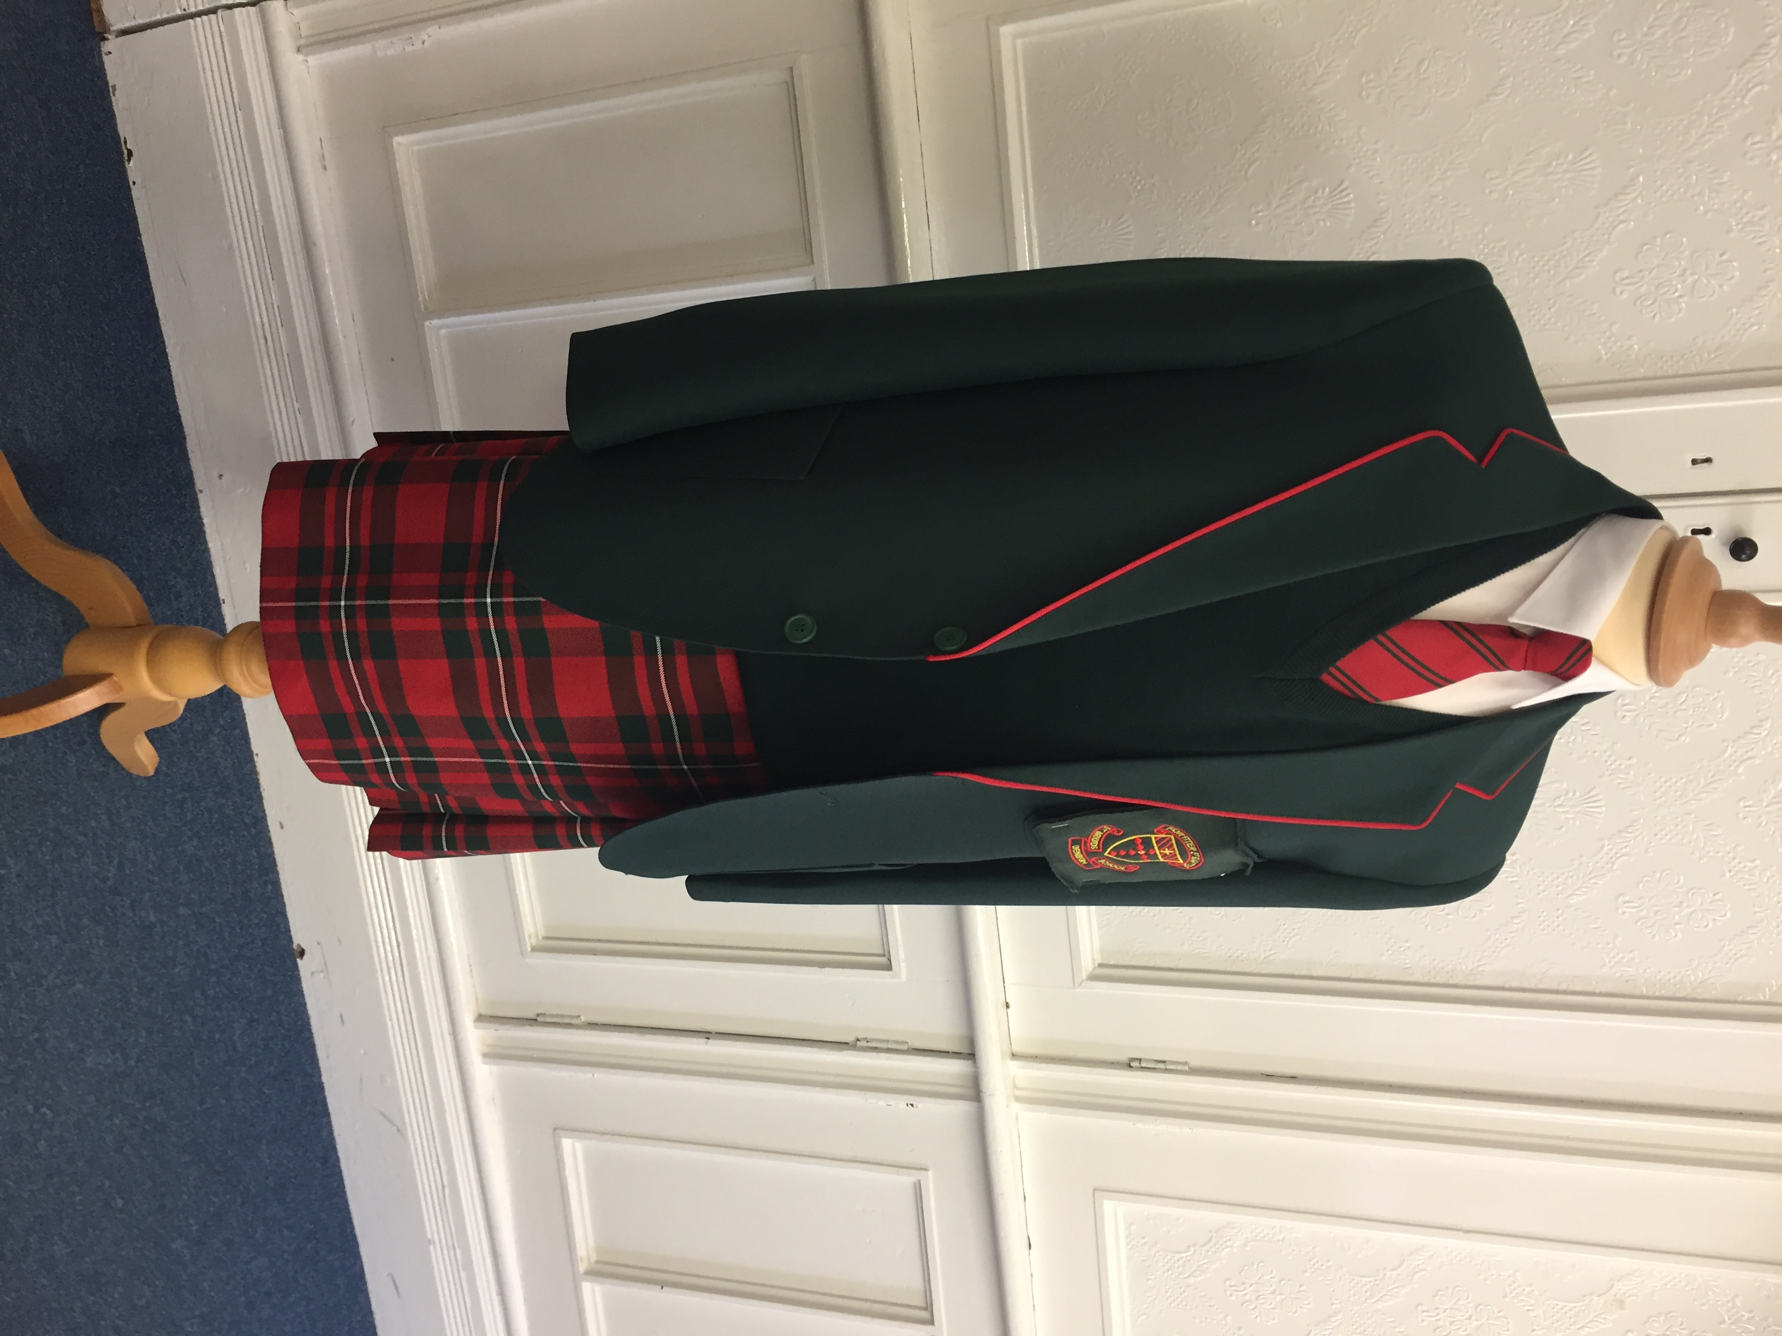
Full School uniform is worn by all pupils during the school day, a Uniform List will be supplied. Forresters/Monkhouse supply our school uniform supplier and they sell uniform online or through Forrester by Monkhouse in Mold.

The School Day

Primary School

Registration: 08.50-09.00
Lesson: 09.00-10.30
Morning break: 10.30-10.45
Lesson: 10.45-Lunch

Lunch: Foundation Phase 11.45-12.45
Lunch: KS2 12.00-12.45

Lesson: 12.45-14.00
Afternoon Break: 14.00-14.10
Lesson: 14.10-15.00

Senior school

Registration: 08.50–09.00 Collective worship/Form time 09.00-09.15

Lesson 1 09.15-10.15
Lesson 2 10.20-11.20
Break 11.20-11.35
Lesson 3 11.35-12.35
Lunch 12.35-13.15
Lesson 4 13.15-14.15
Lesson 5 14.20-15.20

Sixth Form (For all of Dyffryn Clwyd consortium lessons)

Lesson 1 09.45-10.15 Lesson 2 10.15-11.15
Break 11.15-11.30
Lesson 3 11.30-12.30
Lunch 12.30-13.15
Lesson 3 13.15-14.15
Lesson 4 14.20-15.20 (to allow transport to base schools

Arrival: Pupils should arrive at school not later than 08:40 and proceed to their class or form room for registration.

Morning Break: Snacks and drinks are available according to Appetite for Life regulations.

Lunch Pupils are expected to take School Lunch in the Dining Room, in their Form rooms or in the school grounds. Only Sixth form pupils are allowed to leave the School premises during the lunch period.

Dismissal School finishes at 15.00 for Primary pupils and 15.20 for Secondary pupils.

Term Dates 2021-2022

Autumn Term 2021

Wednesday 1st September Staff Training

Thursday 2nd September Autumn Term 1 Begins Nursery – Yr7, 12 & 13

Friday 3rd September Autumn Term 1 Begins All Pupils

Friday 24th September Staff Training Day

Mon 25th October– Fri 29th October Half Term Holiday

Monday 1st November Autumn Term 2 Begins

Sunday 28th November Advent Service

Tuesday 21st December Term Ends

Wednesday 22nd December Schools closed for the Queen’s Platinum Jubilee Bank Holiday.

Spring Term 2022

Thursday 6th January Staff Training Day

Friday 7th January Staff Training Day

Monday 10th January Spring Term 1 Begins

Mon 21st February – Fri 25th February Half Term Holiday

Monday 28th February Staff Training Day

Tuesday 1st March Spring 2 Term Begins

Friday 8th April Term Ends

Summer Term 2022

Monday 25th April Summer 1 Term Begins

Mon 30th May – Fri 3rd June Half Term Holiday

Monday 6th June Staff Training Day

Tuesday 7th June Summer 2 Term Begins

Friday 20th July Term Ends

School standards

Foundation Phase*

Indicator | School %
FPI - Foundation Phase Indicator | 100
Language, Literacy and Communication Skills in English O5+ | 100
Language, Literacy and Communication Skills in English O5 | 100
Language, Literacy and Communication Skills in English O6 | 58.3
Mathematical Development Outcome 5+ | 100
Mathematical Development Outcome 5 | 100
Mathematical Development Outcome 6 | 58.3
Personal and Social Development, Well-Being and Cultural Diversity Outcome 5+ | 100
Personal and Social Development, Well-Being and Cultural Diversity Outcome 5+ | 100
Personal and Social Development, Well-Being and Cultural Diversity Outcome 6+ | 100

Key stage 2*

Indicator | School %
DPC/CSI | 86.0
English L4+ | 89.3
English L4 | 89.3
English L5 | 46.4
Science L4+ | 85.7
Science L4 | 85.7
Science L5 | 35.7
Mathematics L4+ | 89.3
Mathematics L4 | 89.3
Mathematics L5 | 35.7
Welsh Second Language L4+ | 78.6
Welsh Second Language L4 | 78.6
Welsh Second Language L5 | 17.9

Key stage 3*

Indicator | School %
CSI | 72.7
English L5+ | 78.2
English L5 | 78.2
English L6 | 50.9
English L7 | 21.8
Science L5+ | 80.0
Science L5 | 80.0
Science L6 | 49.1
Science L7 | 14.6
Mathematics L5+ | 89.1
Mathematics L5 | 89.1
Mathematics L6 | 43.6
Mathematics L7 | 27.3
Welsh Second Language L5+ | 74.6
Welsh Second Language L5 | 74.6
Welsh Second Language L6 | 36.4
Welsh Second Language L7 | 0

*No FP/KS2/KS3 validated results for 2021

Key Stage 4*

Indicator | School %
Level 1 | 98.2
Level 2 | 85.2
Level 2+ | 77.8
Capped 9 | 415.5
English Language | 90.7
English Literature | 95.0
Mathematics A*- C | 72.2
Numeracy A*- C | 74.1
Science A* - C | 87.0
WBAC Foundation | 85.2
WBAC National | 85.2
5 A*-A | 42.6

Key Stage 5*

Indicator | School %
Level 3 threshold | 100
A*-A | 48.6
A*-C | 97.3
A*-E | 100

*No national comparisons available.

Thank you for taking the time to read about our school. For full details about how to make an application to the school, please see the website:

https://www.st-brigids.co.uk/prospectus-and-information/

